Revision 2.0. - 310510

[Pin-out & Protocol]

Applies to the following models:

PM5639/92 & PM5639/94

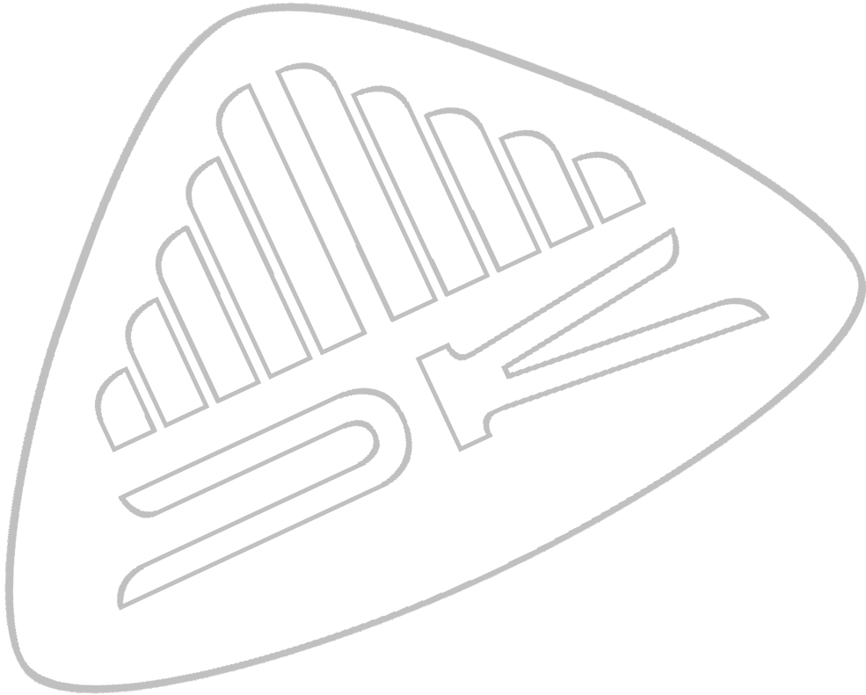

Copyright© 2004 - 2010 DK-Technologies A/S.

This section is only intended for software developers who wish to develop
software to control the PM5639/92 & PM5639/94.

The sensor can be connected to any PC with a RS-232 port. ( or use a USB to RS-232 converter)
The default baud rate is 4800 baud but can be changed. Please, note the the baud rate need to be 4800 if the hand-held display unit is used. The default set-up of the comport is 4800 baud, 8 data bit, 2 stop bit, no parity and no flow control.

Pin Configuration for PM5639/92 & PM5639/94:

9 Pin D-Sub:
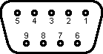
Signal Name. |  | Pin number.
RS232 | RX | 2
RS232 | TX | 3
Power Ground | GND | 5
Power +VCC | 5 volt DC. | 9
 | NC | 1, 4, 6, 7 & 8

View from solder side of the 9 pin MALE D-Sub connector.

Pin Configuration for PM5639/90 & PM5639/91:
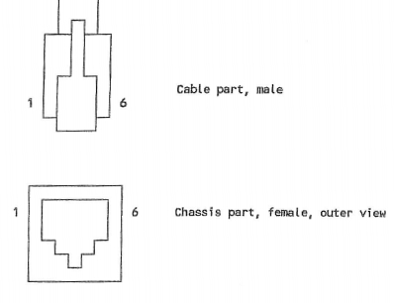
RJ11:
Signal Name. |  | Pin number. | Colour.
Power Ground | GND | 1,2 | White, Yellow
RS232 | TX | 3 | Green
RS232 | RX | 4 | Red
Power +VCC | 5 volt DC. | 5,6 | Black, Blue

Protocol:

Command description | Syntax | Remarks
Take measurement | TM | Transmit one set of measurement data:  Return format in XY mode:  X,Y,Z<CR>  where X, Y & Z are CIE 1931 XYZ-values  Return format in MB mode:  RGB*XX.XX*YY.YY*ZZ.ZZ*<CR><LF>  or  RGB*XXXX*YYYY*ZZZZ*<CR><LF>  or  RGB* 0* 0* 0*<CR><LF>  where X, Y & Z are CIE 1931 XYZ-values  Return format in MX mode:  nX,nY,nZ,INT_TIME<CR>  where nX, nY & nZ are measured values directly from the sensor (Compensated for errors in the DC offset etc.)  INT_TIME ia a value between 2.5 and 25and specifies the integration time in units of 2ms. (This integration time can also be obtained by issuing the command “F?”)
Measure continously | MC | Transmit data continously in present measuring mode. See command TM above for return formats.
Measure stop | MS | Stops transmission of data immediately.
Select CIE XYZ mode | XY | Select transmission of CIE 1931 XYZ values.
Select CIE XYZ mode* | MB | Select transmission of CIE 1931 XYZ values in Barco/Thoma output format.
Select sensor mode | MX | Select transmission of unmodified sensor output
Set integration time | SI n | SI n specifies the number of measurements the sensor handles per second.  The parameter n is expressed in units of 0.2ms where n = 250 gives app. 3 measurements/second, while n = 25 gives app. 10 measurements/second, (25 <= n <= 250)  Default value is 250.  To calculate the number of measurements/second the equation below can be used as a guideline:  measurements/second = 1000/(1.2*n+60)
Get integration time | F? | Return format:  n<CR>  Get integration time gets the actual integration time in the sensor.  The integration time is a value between 2.5 and 25, ie. The return value is specified in units of 2ms. (Note that this number is 10 times smaller that the value used to set the integration time with, see abov)

Command description | Syntax | Remarks
Identity request | I? | The ID-string of the sensor.  Return format:  CP,NO,KU,SW<CR>  where  CP is company name  NO is the type number  KU is the serial number  SW is the software version  eg.  “PTV,400810979300,KU040001,02.1”
Memory address | MA n | Select the address for read/write of serial EEPROM data.
Read memory | RM | Read EEPROM-data, where address is specified by command MA. Address is auto incremented.
Store memory | SM | Write EEPROM-data, where address is specified by command MA. Address is auto incremented.
Read binary numbers | RN n | Reads n+1 bytes from EEPROM, in binary form, where address is specified by command MA. Address is auto incremented by n. The transmission is ended by sendign a checksum-byte. (low byte of addition of n bytes). For n: 0 < n <= 255.
Fix Gain | FG n | Select gain ie. one of 6 gain-areas to be used to “amplify” the signal from the sensor.  (n: 0 <= n <= 5)  Setting n = 255 will release the fixed gain area.
Measure DC offset | MO | Measure DC-offset in sensor. Values will always be calculated when this command is issued. The result however will only be stored if write protection is off. The 6 DC offset values will also be transmitted to the software controlling the sensor.
Show DC offset | SO | Shows the DC offset count to be subtracted in present gain. To get back to normal mode use command NR.
Show true sensor count | ST | Shows the direct count from the AD-converter. To get back to normal mode use command NR.
Normal mode | NR | Force the sensor in “normal mode” ie. MX-mode
Calculate Checksum | CS | Calculate the program checksum.
Set Baurate | SB n | Change baurate to n: 48 (4800 baud), 96 (9600 baud), 192 (19200 baud).  Default 4800 baud.

